Quality Domains in Education
The regulator of postgraduate medical education also offers a structure for quality assurance. The GMC Guidance can be found in the Quality Improvement Framework for Undergraduate and Postgraduate Medical Education and Training in the UK (GMC 2011)¹

The PMETB Quality Domains
Domain 1  Patient safety | The duties, working hours and supervision of trainees must be consistent with the delivery of high quality safe patient care.  There must be clear procedures to address immediately any concerns about patient safety arising from the training of doctors.
Domain 2  Quality Management, review and evaluation | Postgraduate training must be quality managed locally by deaneries, working with others as appropriate e.g. medical Royal Colleges/Faculties, specialty associations, training providers.
Domain 3  Equality, diversity and opportunity | Postgraduate training must be fair and based on principles of equality.
Domain 4  Recruitment, selection and appointment | Processes for recruitment, selection and appointment must be open, fair, and effective and those appointed must be inducted appropriately into training.
Domain 5  Delivery of approved curriculum including assessment | The requirements set out in the approved curriculum, approved by PMETB, must be delivered.  The approved assessment system must be fit for purpose.
Domain 6  Support and development of trainees, trainers and local faculty | Trainees must be supported to acquire the necessary skills and experience through induction, effective educational supervision, an appropriate workload and time to learn.
Domain 7  Management of education and training | Education and training must be planned and maintained through transparent processes which show who is responsible at each stage.
Domain 8  Educational resources and capacity | The educational facilities, infrastructure and leadership must be adequate to deliver the approved curriculum.
Domain 9  Outcomes | The impact of the standards must be tracked against trainee outcomes and clear linkages should be reflected in developing standards.

Defining indicators for the dimensions of quality
Remember:
- It is unnecessary to choose an indicator and/or a threshold for every standard or specification.
- Information sources include interviews, complaints, appraisal, e-portfolios, multi-source feedback, patient feedback and so on. However, the important point here is to keep data collection to a minimum – we need to minimise the burden of data collection on our workers. And where possible, try and use data that these workers either use in their daily work or that they will find helpful in their daily work (provides a basis for constructive dialogue).
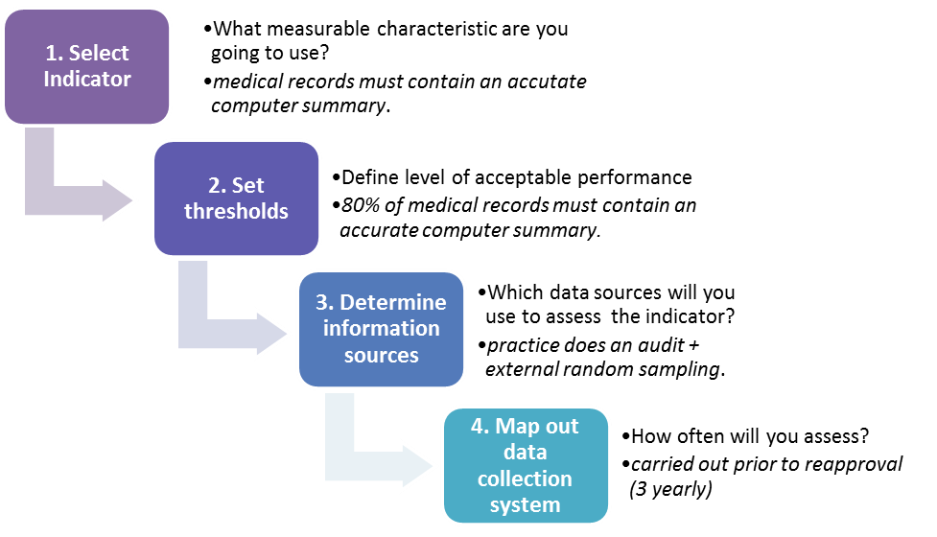
- During the initial phase of a monitoring system, health workers will need assistance in collecting and using data.

The following table is an example of how one deanery sets quality standards around PMETB domain 1.1: ‘Trainees must make the needs of patients their first concern’

PMETB Statement 1.1 = Trainees must make the needs of patients their first concern
Standards we expect from training practices: | - Reliable communication systems exist between members of the PHCT.  80% of the medical records must contain a computer summary list, record of prescribing and where appropriate evidence of health promotion and planned management.  The practice has a protocol for updating summaries.  - Practice should usually achieve at least ‘average’ QOF points score.  - Children at-risk are easily identifiable  All members of the team are aware of appropriate communication pathways  in reporting child protection or other vulnerable patient safety concerns.  - The practice surveys and responds to the views of its patients
The evidence which we will judge them on: | - An audit of practice records (& protocol for updating them)  - Details of and commentary on most recent achievement in Quality and Outcomes Framework.  - The Practice Guide should detail how the trainee makes contact with different members of the PHCT and child protection reporting pathways.  - Patient survey results.
Standards we expect from Trainers: | - An explicit process exists for the trainee to gain access to the Trainer or deputy during consultation hours.
The evidence which we will judge them on: | - Practice Guide  - Trainee interview – how easy is the access?
Practice Guide refers to the document available to each GP trainee detailing day-to-day practice organisation and other information of relevance to them for the particular training practice they are attached to.
Triangulation in education
There is often an overlap in data and obtaining data from different sources can improve reliability and tell a more accurate story. Try and develop different ways of looking at the same thing to see if they match (whether that version of ‘the truth’ is real). Over reliance on one method of assuring quality is a source of error. ‘If your only tool is a hammer, then all your problems will be nails’.
As an Educational Supervisor, I noticed that one of my trainees seemed to have ‘Needs Further Development’ grades for the competency ‘Working with Colleagues and in Teams’ in a number of his Case Based Discussions (CBDs). That was pretty odd because I got on well with him and thought he was of quite a personable nature. So, was I getting a skewed picture from his CBDs or was my own face-to-face interpretation of his personable nature a wrong picture? I decided to triangulate by looking at his recent Multi-Source Feedback (MSF) and his Clinical Supervisor’s Report (CSR) - both of these assessments have specific elements about working with colleagues and in teams. I was relieved to see a glowing MSF and CSR which I felt were stronger indicators of this competency because they kind of measure what the trainee does rather than what they say they do.

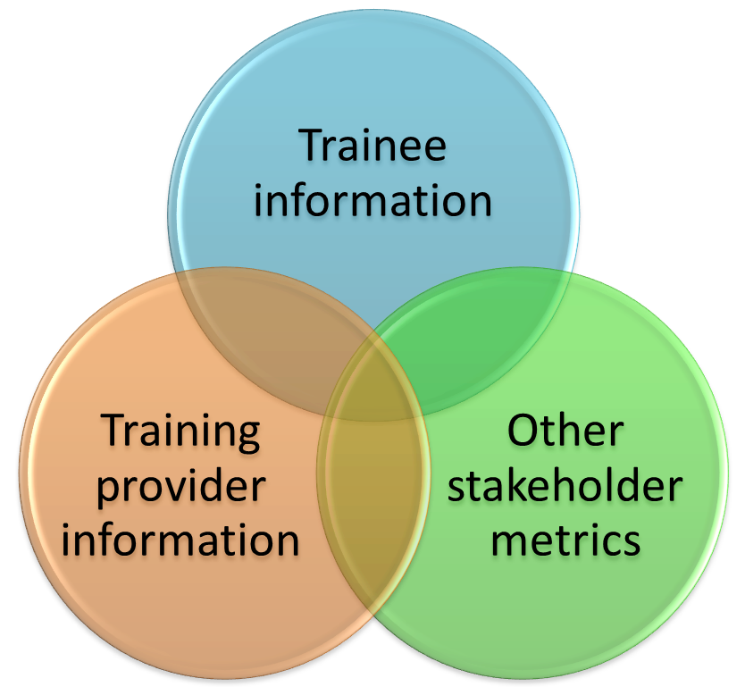
This vignette demonstrates triangulation in terms of checking out competencies. Something similar needs to be done when checking out quality: consider looking at data from the overlapping metrics in this Venn diagram.
- Trainee data: feedback, significant events (triggers), surveys (internal and external), attendance, curriculum coverage, assessments, ARCP, CSA, AKT, completion rates.
- Training Provider data: facilities, staffing, policies (e.g. induction), teaching syllabus, trainer appraisal, feedback from other educators and peer review, trigger events, visits and inspections (triggered visits, routine visits, themed visits), attendance, trainer qualifications, assessment of teaching skills, clinical quality markers (QoF, patient safety data etc.).
- Wider metrics: training outcome data, examination data, completion/attrition rates, equality and diversity data, economic data, annual reports.

Perhaps the most important triangulation is between education governance and clinical governance. If we place our trainees in environments where clinical governance (clinical processes and clinical outcomes) are poor ...then our trainees are likely to emulate poor practice. It is possible to have good service and poor training (i.e. good clinical governance and poor education governance is possible), but it is very unlikely to have poor service and good training (i.e. poor clinical governance and good education governance is almost impossible). Perhaps the most dramatic example of this is the report of the Care Quality Commission into the Mid Staffordshire Hospitals NHS Trust², where identified poor education and training ought to have raised concerns about the standards of clinical care.

Quality assurance or triangulating through visits
One of the most popular quality assurance tools is the visit. We have already stated the danger of over reliance on one tool for quality assurance. If you are thinking of employing ‘the practice visit’, make sure it doesn’t become a bureaucratic, complex, high stakes, mini-accreditation tool in itself.

Instead, use the practice visit to
- understand context
- see actual practise at ground level and to
- feel the quality culture of an organisation.

The ‘Executive walk around’ is a form of visit. The ‘Leadership walk around’³ is a good tool for improving patient safety; more can be found at www.patientsafetyfirst.nhs.uk
Different ways of visiting:
Scheduled visits - part of a regular plan of periodic visiting to all training providers.
Sampling - a sample of training providers is visited. For example as part of an annual visit to a training programme a random sample of training practices could be visited.
Triggered visits – where a sentinel event triggers a targeted visited.
Themed visits – a particular theme, often identified by another quality indicator, is the subject of the visit.

Comprehensive visits where the visiting team ‘turns over every stone’ are characteristic of low trust highly regulated systems. So too are ‘drill down’ visits where there is thorough exploration and analysis of certain key areas of enquiry, which may or may not have been agreed in advance.

Synthesis and Judgement
A typical approach is to review quality data periodically. The period can be annual, (e.g. for the purposes of providing an annual report on the quality of training), or the period can be for longer timescales, (e.g. limited approval for x years). A ‘periodic’ approach to quality is a pragmatic way of making sure that progress is reviewed. However, it also runs contrary to our earlier assertion that quality improvement is a comprehensive and continuous process.

There are, however, other approaches:

- Triggers – sentinel events may be used to trigger more detailed review of the quality of training.
- Review precipitated by external regulatory review. (Looking to our laurels!)
- Continuous monitoring: using ‘Dashboard’, ‘Scorecards’ and ‘RAG ratings’.

Dashboards and scorecards are ways of grouping and presenting important data from a variety of sources. Dashboards and scorecards enable organisations to measure how well they are doing and compare themselves with others. They also allow other stakeholders to do the same. NHS Hertfordshire has produced a score card which you can see on our website. Perhaps you can tweak it to develop something for your own purpose (benchmarking GP practices, GP training practices, GP training schemes or dare we say GP consortia!).

By the way, RAG stands for Red, Amber, Green and is a visual way of indicating progress or level of risk – sometimes called the Traffic Light Rating System⁴.

References
- Quality Improvement Framework for Undergraduate and Postgraduate Medical Education and Training in the UK (GMC 2011) available from http://www.gmc-uk.org/education/9038.asp
- http://www.cqc.org.uk/_db/_documents/Investigation_into_Mid_Staffordshire_NHS_Foundation_Trust.pdf
- http://www.institute.nhs.uk/safer_care/general/leadership_walkaround.html
- http://en.wikipedia.org/wiki/Traffic_light_rating_system

